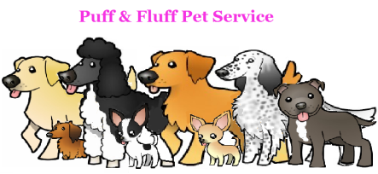________________________________________________
508-207-0130 Emergency Contact
& Vet Authorization

Emergency Contact Information

Your emergency contact should be someone local and someone that, in the event of emergency, has access to your home.

Emergency Contact Name ______________________________________
Home Phone __________________
Work Phone __________________
Cell Phone __________________

Vet Information and Release Form

Vet Clinic ____________________________________________________
Address ___________________________________ City ________________ State _____ Zip _______

Phone _____________________________

I understand that in the event of an emergency, Puff & Fluff Pet Service will make every attempt to contact me. In the event that I cannot be reached, I authorize the following:
In the event of illness or injury, I authorize Puff & Fluff Pet Service Not to seek appropriate medical treatment for my pet. I understand that every effort will be made to take my pet to the vet clinic specified on the emergency form if the situation permits however; Puff & Fluff Pet Service has the authority to seek treatment at any veterinary clinic. Furthermore, I agree to reimburse Puff & Fluff Pet Service within 14 days of incident for veterinary fees and all related costs including transportation in any amount up to $_____________ (please specify dollar amount per pet. Common amounts are $200, $1000, or unlimited).

This release does not expire and will remain valid for all future Puff & Fluff Pet Service.

Client Signature _____________________________________ Date _______________
Printed Name _______________________________________

